### Topic6: How to visualize competence: the Issue of Occupational Information Network Visualization

* Data interpreting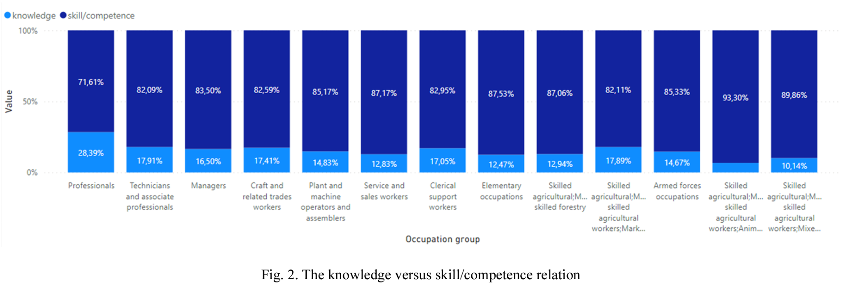

Moreover, in fig. 2 the two clusters were developed. The first combine all objects related to the knowledge category, the second associates all objects related to skill/competence. The interesting result is a big disproportion between these two clusters. The skill/competence part is always much bigger than knowledge. The skill/competence are built as a continuous learning process during which the information is assimilated and the body of facts, principles, theories and practices that is related to a field of work or study.  
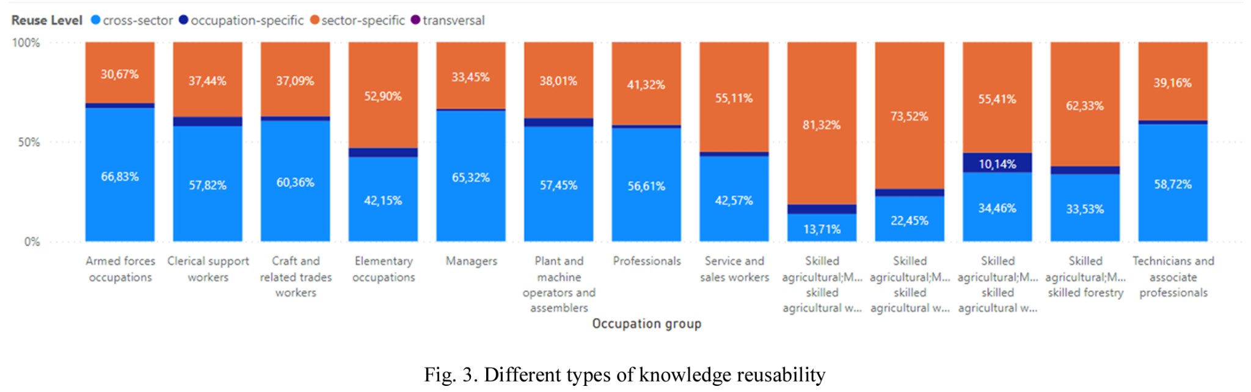  
 The last graphic (on Fig. 3) presents the reusability of knowledge and skill/competence between occupations. In order to make knowledge transferable, the knowledge has to be expressed in explicit form. Transversal knowledge, skills, and competencies are relevant to a broad range of occupations and economic sectors. They are often referred to as core skills, basic skills, or soft skills, the cornerstone for the personal development of a person. Moreover, we distinguished cross-sector, occupation-specific, sector-specific, and transversal types of knowledge (fig. 3). The biggest part is usually sector-specific and cross-sector.